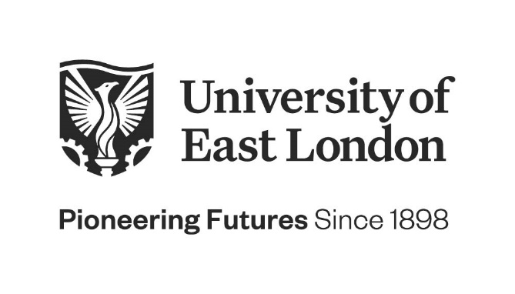
JOB DESCRIPTION

Job title: | Research, Impact and Corporate Communications Manager
Grade: | F
Service: | External Relations Directorate
Location: | Docklands, Stratford, USS
Responsible to: | Deputy Head of Digital Media and Corporate
Liaison with: | Colleagues across the External Relations Directorate, BOG, UMB, UEB, Impact and Innovation, internal and external partners

Build your career, follow your passion, be inspired by our environment of success
#BeTheChange

THE UNIVERSITY OF EAST LONDON

The University of East London is one of the most diverse and vibrant universities in the global capital. Our pioneering and future-focused careers-first vision is making a positive and significant impact to the communities we serve, inspiring our students, our staff, our alumni and our partners to reach their full potential.

Founded in 1898 to meet the skills needs of the 2nd industrial revolution, we are implementing Vision 2028 our ambitious 10-year strategy to reshape the face of education through collaborative initiatives alongside industry partners.

Our mission remains to foster inclusive pathways to career readiness for students of all backgrounds whilst driving positive change and measurable impact through our research, global partnerships, and innovative educational models.

We are building an environment of success where colleagues are supported to achieve, and our community can flourish and thrive. We are an accredited Investors in People Award Institution and have achieved the Investors in People Health and Wellbeing Award. As the only University in London to have achieved Silver Awards in Athena Swan Gender Equality and in the Race Equality Charter, we continue our journey to address and reduce barriers to opportunity.

THE SERVICE -External Relations Directorate
We have built an External Relations Directorate that has brought together an integrated Communications & Engagement and Student Recruitment & Marketing service. The directorate is made up of several teams including Communications & Engagement, Marketing, Recruitment and Conversion, Outreach and Access, Change and Transformation (Design and Digital), Events and Advancement and the International Office.
We are looking for team members who will be part of embedding transformation and innovative practice and enjoy working in an agile environment as we try and work towards a culture of the ‘continuous new’. This is an exciting opportunity as we prioritise building our global and UK profiles with key elements from Vision 2028.

JOB PURPOSE

The Research, Impact and Corporate Communications Manager will craft, execute and assess the University’s research communication strategies, with a particular focus on sustainability, health and the data economy. The postholder will also lead on other key corporate communications projects, positioning and promoting key strategic people and products in alignment with Vision 2028.

This is a highly visible role and the postholder should exhibit excellent communication skills and presence and a passion for internal and external relationship building. You will have a strategic mindset and the ability to produce captivating written and digital content that weaves the UEL story into compelling narratives that resonate with key corporate stakeholders.

The Research, Impact and Communications Manager possesses a strong understanding of how social media and other digital platforms can be leveraged to build and enhance reputation and credibility with a variety of stakeholders. You will have strong writing and presentation skills, the ability to translate complex ideas into easily understood material and the ability to work with and for diverse groups.

We are looking for someone who is a self-starter and can produce results in a fast-paced work environment with multiple, often shifting priorities and often under minimal direction. You should be highly detail-oriented and excited about engaging and inspiring your colleagues to promote research at UEL.

MAIN DUTIES AND RESPONSIBILITIES

- Design and implement effective communications strategies to promote research and other corporate priorities to key internal and external audiences, particularly on social media and digital platforms, with the goal of enhancing reputation, credibility and brand.
- Create compelling and strategic digital content (4+ pieces/month), including videos, podcasts and LinkedIn Live events, for social media, website, blogs and other platforms.
- Develop and execute written communications of a complex nature, including press releases, speeches, presentations, newsletters, publications, thought leadership and opinion pieces, correspondence and social media posts
- Synthesize complex materials and communicate information in a manner easily understood
- Identify, generate and maintain relationships with research academics, institutional leadership teams and internal and external partners to identify newsworthy people and events and promote and disseminate information.
- Work with the Deputy Head of PR and Communications to develop and execute a training strategy to improve media, social media and other communications skills for senior leadership and research colleagues
- Work with the Deputy Head of PR and Communications to identify and pitch PR opportunities
- Monitor media, social media and digital coverage; analyse digital metrics and prepare reports to evaluate the effectiveness of content, campaigns and other communications.
- Support the University’s crisis communication response including emergency matters
- Ensure consistent messaging and branding across all communication channels and materials, maintaining brand integrity and identity
- Any other duties deemed relevant and necessary by the Head of Communications

The duties and responsibilities outlined above provide a general overview of the range of tasks that a Research, Impact and Corporate Communications Manager at the University of East London may be required to perform. Please note that this job description is not exhaustive, and additional tasks aligned with the role's grade may be assigned as needed.
The job description may also be updated to reflect changes in circumstances, and employees will be consulted if any amendments are required.

PERSON SPECIFICATION

KNOWLEDGE, SKILLS AND ABILITIES:

- Excellent verbal and written communication skills, with proven ability to present, write, edit, and organize thoughts in a clear, concise, clear, concise, and well-organized manner
- Ability to translate complex materials and communicate highly technical information in a manner which is easily understood
- Ability to change voice and writing style to fit a particular audience and purpose
- Outstanding interpersonal skills and ability to interact effectively with a diverse array of people, including senior leaders
- Excellent digital content creation skills, including shooting and editing video; producing podcasts and other audio content and creating newsletters
- Ability to create and execute communications training programmes for academic colleagues
- Highly skilled in Microsoft Office Suite, Sharepoint, Drupal and other content management systems (CMS), project management tools, Adobe Creative Suite and other systems as needed.
- Excellent understanding of SEO (Search Engine Optimisation) and writing for optimal website engagement
- Experience motivating and engaging with diverse individuals and groups
- Excellent organisational and planning skills with the ability to manage multiple competing priorities and meet urgent, tight and/or demanding deadlines
- Ability to produce content quickly and turn around requests at very short notice
- Demonstrated ability to take initiative, think and act proactively and horizon scan for future opportunities
- Excellent strategic planning, project management and problem-solving skills.
- Ability to maintain discretion when handling sensitive information and exercise sound judgment, tact and diplomacy

PERSONAL ATTRIBUTES AND QUALITIES

- Demonstrated interpersonal skills in working with a variety of people; the postholder must practice respectful relationship management both internally with team members and colleagues and with external partners
- Ability to present training materials in an engaging and confident manner
- Driven to learn, acquire new skills and expand professional knowledge
- Commitment to and understanding of widening participation in higher education as well as equality and diversity issues within a diverse and multicultural environment

WORKING CONDITIONS

- Ability to work occasional evenings and weekends

EDUCATION QUALIFICATIONS AND PROFESSIONAL ACHIEVEMENTS

- A minimum BA Hons. and/or equivalent professional experience in communications, Higher Education, public relations or journalism
- Substantial experience working in communications, Higher Education, public relations or journalism.

