University of East London
Candidate Brief

School Director of Education &
Experience

School of Psychology

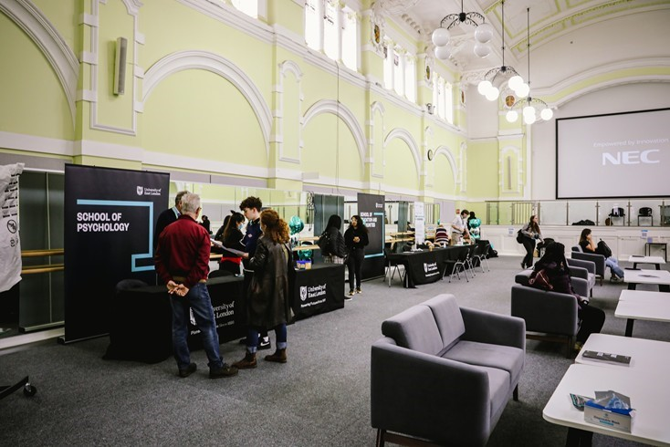
Message from Professor Amanda
Broderick - Vice Chancellor &
President University of East London
Thank you for your interest in for the role of School Director of Education & Experience & Reader/ Professor in Psychology at the University of East London.
This is an exciting time for the university with the university’s commitment to our mission to advance Industry 4.0 careers and lives, where we expand mental wealth, create careers, build business and connect communities in East London and beyond through our global gateway, local anchor.
Our Vision 2028 is a 10-year strategy that will see University of East London being at the forefront of careers-led education - a springboard for the jobs and opportunities of the future. We have developed a range of extra career experience opportunities in the form of a career passport for student to add to their skills and CV alongside our dedicated career zones to ensure we bring students, industry and career specialists closer together.
This is a perfect opportunity for an ambitious and enthusiastic professional willing to make a difference to the lives of our students. We are looking forward to receiving your application.
Professor Amanda Broderick, Vice Chancellor & President, University of East London.

Our new vision
Vision 2028 is a 10-year strategy to be at the forefront of careers-led education - a springboard for the jobs and opportunities of the future.
It aims to drive diversity in the 4.0 talent pipeline to give graduates the skills, tools and competencies sought by employers and entrepreneurs in a rapidly changing world, likely to become even more relevant in an employment landscape altered by the Covid-19 pandemic.
The strategy builds upon the institution’s long-standing commitment to inclusion and social mobility, and advances research and entrepreneurial knowledge to produce solutions that help people, our community, a greener planet and the sustainability of our future.
Our priorities remain resolute in our mission: driving career-ready student inclusion, increasing our reputation for the benefit of our alumni and social impact of the university.
Our ambitious vision is to become the leading careers-intensive university in the UK, committed to realising and developing talent and potential in all those who become part of the University of East London’s community. UEL is the start of an exciting journey that promises to develop potential and help students realise their dreams.

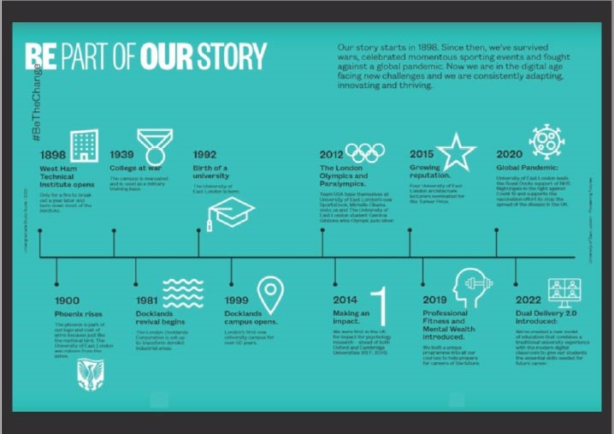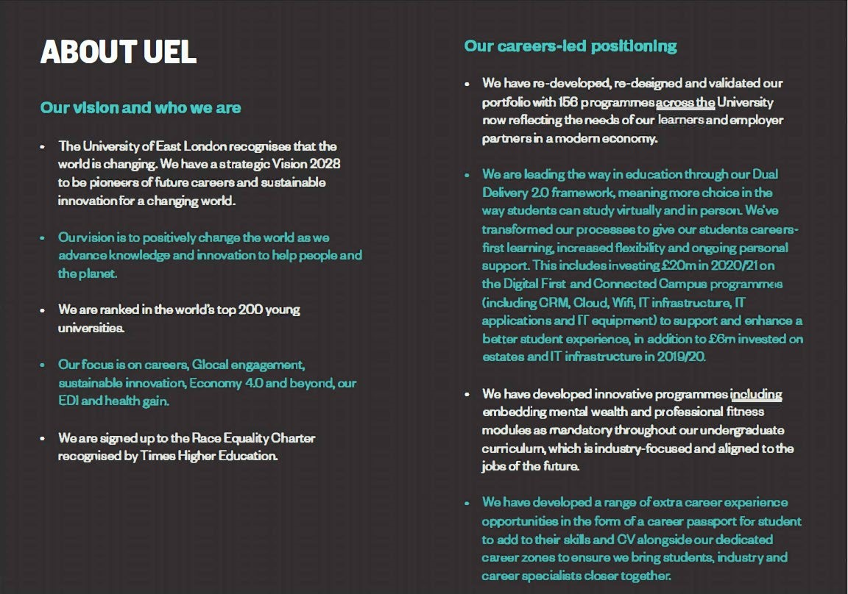

School of Psychology
The School of Psychology is a vibrant and growing school at University of East London. With a clear focus on creating graduates of the future, we are a key School within an ambitious University. Based in a fast growing and diverse environment of East London the School is well positioned in a community benefiting from substantial inward investment and regeneration.
A number of exciting projects are taking place in the School including the introduction of Mental Wealth modules across all courses designed to accelerate career opportunities for our students. In addition, two new Centres of Excellence are being developed in the School and will connect knowledge acquisition, personal growth and professional experience for our students and graduates providing them with skills and innovative solutions relevant for the future of work.
We take pride in all our staff and students who are talented, hardworking and come from a rich diverse background. We are driven to providing the best qualifications, practical ability and career support that allows our students and graduates to have the best possible chance of developing a great career in their chosen field. Our academics deliver original and innovative teaching ensuring that students are academically challenged. If you are an ambitious and creative individual who wants work for a University with a bold vision, then we invite you to join the School of Psychology at this exciting time. You will participate in delivering our provision in a fast-changing market and deliver a distinctive education focused on future proofing the skills of our students.
Professor Aneta Tunariu
Dean of School of Psychology
University of East London

JOB DESCRIPTION

Job Title: Director of Education & Experience Psychology (4 years secondment)
Substantive Permanent Post
Reader/Professor of Behavioural Science or Forensic Psychology

Grade: Academic (non-substantive management role with non-pensionable honorarium)

Responsible to: Dean of School with dotted line connection to Pro-Vice Chancellor
Education & Experience

JOB PURPOSE

A transformational strategic route-map was launched in early 2019 plotting our course to become the pioneering Careers-led University for a changing world, where the future of learning and work is advanced today and Potential is realised wherever and whenever it is found.

As Director of Education & Experience you will be part of the School Management Team, Dean of School Steering Group and lead on priorities relating to School academic standards, quality of provision as well as addressing student engagement and participation, progression, student academic experience, successful attainment of life-changing, and lifelong education & training.

The role leads on enhancing student outcomes, innovating industry-embedded practice across undergraduate and postgraduate education for a changing world; the operationalisation of the ‘Mental Wealth programme’ and the successful implementation of the School’s Education & Experience development plan. The strategic objective is measured through TEF KPIs.

The responsibilities fall into the following broad areas:

- To champion, develop and lead the delivery of the school’s plans relating to education and the student experience, to improve student success, to deliver improved retention and progression, to advance excellence in learning and teaching, to assure the quality of the University’s academic programmes and to deliver improvements to the University’s TEF metrics and commitments to its Access and Participation Plan.

- To partner effectively with students, empowering the student voice and delivering an effective interface between industry-facing education, applied research and community engagement.

- To lead the development and delivery of new and existing initiatives, school wide and in partnership, related to learning, teaching, and co- and extra- curricular activity.

- As a member of the School’s senior management team, to contribute to matters affecting the school including business performance and sustainability.

The successful applicant will have extensive experience of School Management leadership level, substantive track record of impactful research at reader/professorial level and an inclusive, determined and inspirational approach to leadership, encouraging ideas, initiative and innovation in others whilst establishing a cost- effective and high-performance culture based on continuous improvement. They must be able to build strong and purposeful internal and external stakeholder relationships with partners and potential partners and play a key strategic role in enabling the school to fulfil its potential.

MAIN DUTIES AND RESPONSIBILITIES

- Serve as a member of the School SMT working effectively across the School to drive sustainable growth in critical strategic areas;

- To deliver activities that contribute to improved student access, continuation and success;

- Working closely with key stakeholders, design and embed a distinctive curriculum/portfolio of cross-cutting programmes that build mental wealth (emotional, social, physical intelligence), digital proficiency and cultural intelligence;

- Deliver outcomes that improve the student experience and satisfaction, including teaching, assessment and feedback;

- Lead the improvement of student success rates in critical areas including continuation, completion of degrees, achievement of good honours results and the realisation of added value for students;

- To support the Dean of School in delivering organic and diversified portfolio growth;

- To take a leadership role in their area of expertise (i.e. Environmental Psychology/Behavioural Change or Forensic Psychology) and help related undergraduate courses achieve fullest potential.

- To actively promote equality and diversity, in accordance with UEL’s equality and diversity policies;

- Any other duties appropriate to the role as appointed by the Dean of School.

Person Specification

Qualifications & Training:

Essential;

- A doctorate (PhD or Professional Doctorate) or equivalent evidence of professional experience and profile commensurate with a senior leadership role (A/C)

- A credible professional track record with evidence of delivering substantive performance improvements aligned with portfolio (A)

- A substantive evidence of impactful research aligned to reader or professorial standards in one of these two specialisms (Environmental Psychology/Behavioural Change or Forensic Psychology) (A)

Knowledge and Experience:

Essential;

- A track record of providing leadership and direction in the development of strategies related to the school’s portfolios (A)

- Experience of delivering performance improvements relating to Education and Experience (A)

- Knowledge and awareness of the broad context of Higher Education and government policy in the UK, with both current and forthcoming challenges and opportunities it presents (I)

- A broad understanding of the differing needs and modes of education across their school, new modes of delivery including experience in developing and the delivery of on-line education (A/I)

Skills & Competencies:

Essential;

- Ability to provide effective leadership on policy and strategy in the school’s portfolio (A)

- Experience in driving high quality, and in supporting academic colleagues to maintain high performing courses and a structured approach to planning (A)

- A proven track record of managing complex projects and engaging staff and stakeholders through this process (I)

Leadership, Management & Teamwork:

Essential;

- Excellent leadership skills, including a commitment to high performance and continuous improvement (A)

- Demonstrable ability to focus on key priorities and deliver results (I)

General attributes & Personal Qualities/Other:

Essential;

- Ability to unite diverse stakeholders to deliver common goals and a creative and innovative approach to problem-solving (I)

- Demonstrable contribution to equality, diversity and inclusion and embedding of such in the current or previous organisation and/ or community (I)

- Ability to cultivate strong networks and build links with the wider community and with business, industry and other stakeholders and represent the University (I)

Criteria tested by Key:
A = Application form
C = Certification
I = Interview
T = Test

